

**UNIVERSIDAD TECNOLÓGICA DE**

**SAN LUIS RIO COLORADO**

**JOINS**

**MTRA. DERBEZ VILLEGAS ARIADNA ALEJANDRA**

**ALUMNO: VICTOR MANUEL GALVAN COVARRUBIAS**

San Luis Rio Colorado, Sonora Agosto 2020

**SQL JOIN**

A **JOIN** clause is used to combine rows from two or more tables, based on a related column between them.

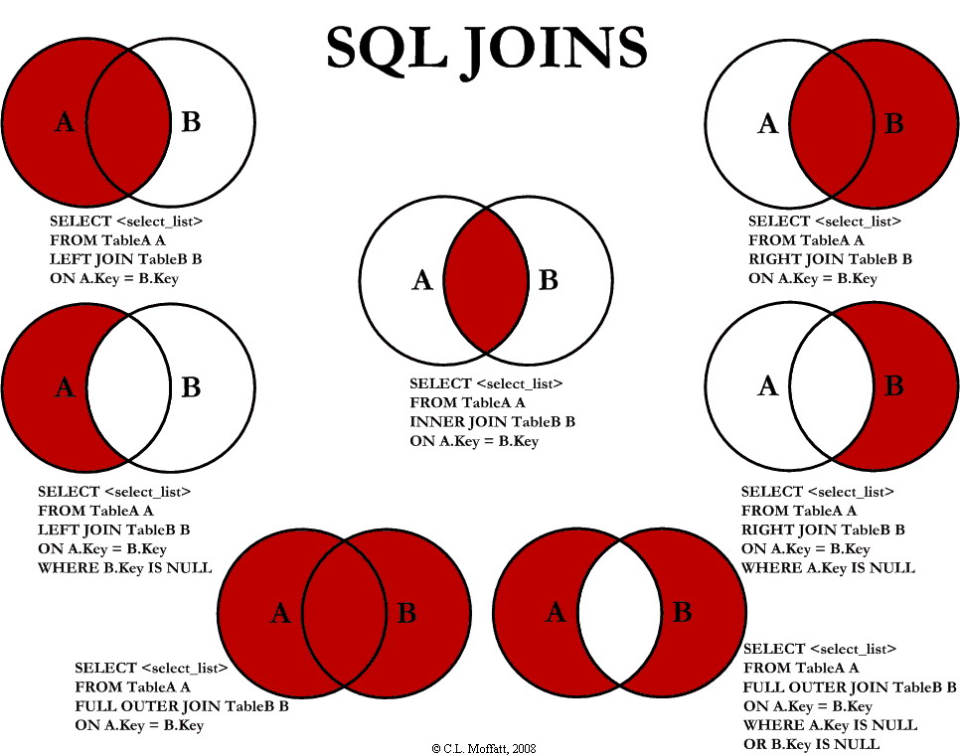

**Types of joins:**

**SQL INNER JOIN Keyword**

The INNER JOIN keyword selects records that have matching values in both tables.

SELECT column_name(s)  
FROM table1  
INNER JOIN table2ON table1.column_name = table2.column_name;

**SQL LEFT JOIN Keyword**

The LEFT JOIN keyword returns all records from the left table (table1), and the matched records from the right table (table2). The result is NULL from the right side, if there is no match.

SELECT column_name(s)  
FROM table1  
LEFT JOIN table2ON table1.column_name = table2.column_name;

**SQL RIGHT JOIN Keyword**

The RIGHT JOIN keyword returns all records from the right table (table2), and the matched records from the left table (table1). The result is NULL from the left side, when there is no match.

SELECT column_name(s)  
FROM table1  
RIGHT JOIN table2ON table1.column_name = table2.column_name;

**SQL FULL OUTER JOIN Keyword**

The FULL OUTER JOIN keyword returns all records when there is a match in left (table1) or right (table2) table records.

**Note**: FULL OUTER JOIN can potentially return very large result-sets!

Tip: **FULL OUTER JOIN** and **FULL JOIN** are the same.

SELECT column_name(s)  
FROM table1  
FULL OUTER JOIN table2ON table1.column_name = table2.column_nameWHERE condition;